|  |  |  |  |  |  |  |  |  |  |  |  |  |  |  |  |  |
| --- | --- | --- | --- | --- | --- | --- | --- | --- | --- | --- | --- | --- | --- | --- | --- | --- |
| Clustering (before) | 1 | 2 | 3 | 3 | 4 | 5 | 5 | 7 | 10 | 11 | 13 | 14 | 15 | 17 | 20 | 21 |
| 1 | 1 | 2 |  |  |  |  |  |  |  |  |  |  |  |  |  |  |
| 3 |  |  | 3 | 3 | 4 | 5 | 5 |  |  |  |  |  |  |  |  |  |
| 8 |  |  |  |  |  |  |  | 7 | 10 | 11 | 13 | 14 | 15 | 17 | 20 | 21 |

The means for cluster 1,3,8 are 1,4,14

|  |  |  |  |  |  |  |  |  |  |  |  |  |  |  |  |  |
| --- | --- | --- | --- | --- | --- | --- | --- | --- | --- | --- | --- | --- | --- | --- | --- | --- |
| Clustering (After) | 1 | 2 | 3 | 3 | 4 | 5 | 5 | 7 | 10 | 11 | 13 | 14 | 15 | 17 | 20 | 21 |
| 1 | 1 | 2 |  |  |  |  |  |  |  |  |  |  |  |  |  |  |
| 4 |  |  | 3 | 3 | 4 | 5 | 5 | 7 |  |  |  |  |  |  |  |  |
| 14 |  |  |  |  |  |  |  |  | 10 | 11 | 13 | 14 | 15 | 17 | 20 | 21 |

The Cost equals to:

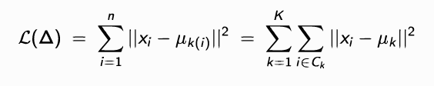

Cost:

